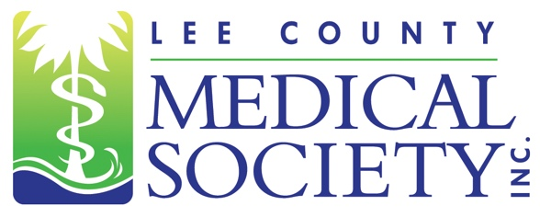
NEWS FOR IMMEDIATE RELEASE
Contact: Julie Ramirez, Executive Director
jramirez@lcmsfl.org
(239) 936-1645

Lee County Medical Society Releases Video Featuring
Local Healthcare Leaders Promoting COVID-19 Vaccination

Fort Myers, FL (August 25, 2021) – The Lee County Medical Society (LCMS) has produced a short public video featuring several messages from physician leaders across the Lee County healthcare community on the importance of vaccination to reduce COVID-19 infections.

“Our physicians are on the front lines watching this pandemic spike in our community,” said LCMS President Dr. Elizabeth Cosmai. “The video demonstrates our joined efforts as medical professionals to communicate a singular message of dire importance: vaccinate!”

Dr. Cosmai also stressed that “the COVID-19 vaccine can help reduce infection rates, is effective against the Delta variant, and will reduce the severity of symptoms in a person who is infected with SARS-CoV-2.”

The Lee County Medical Society, through this public service announcement, wishes to send a strong and encouraging message to the vaccine-reluctant that COVID-19 vaccination is safe and is the most effective way to reduce the number of infections and deaths in the community caused by the SARS-CoV-2 virus and its genetic variants.

“Media reports show our local hospitals are at or beyond capacity because of COVID-19,” added LCMS Executive Director Julie Ramirez, CAE, “but it does not shed light on the situation unfolding in our physician member offices. There are hundreds of COVID-19 patients in area hospitals; but there are also hundreds of COVID-19 patients seeking treatment at local clinics and doctor practices daily. These physicians and allied healthcare providers are working very hard to help patients experiencing symptoms from COVID-19. But without vaccination, some of these patients will inevitably require admission to the hospital.”

The short video can be viewed and shared from LCMS’ YouTube page, Facebook page, and website.

Lee County Medical Society is a professional organization of over 800 physician members practicing in Lee County, Florida. Its mission is to advocate for physicians and their relationships with patients; promote public health and uphold the professionalism of the practice of medicine. Since 1927, the Society has been a trusted source of medical/health leadership in Lee County. The Society also provides programs to educate physicians of all specialty areas while encouraging professional integrity and unity. The Society operates from a virtual office. For more information, go to www.lcmsfl.org.

