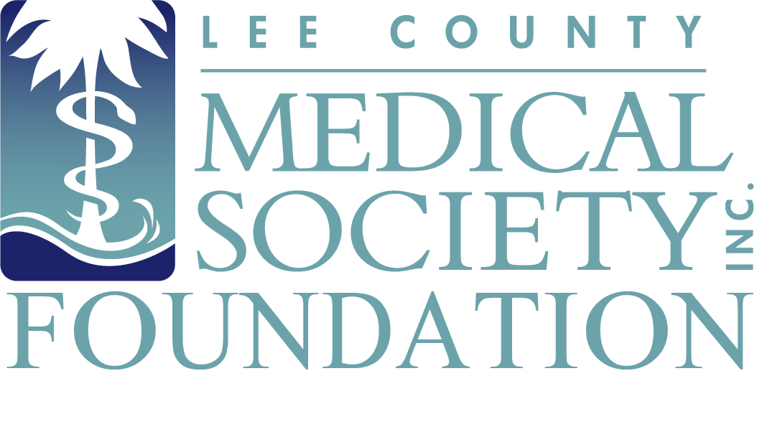
NEWS FOR IMMEDIATE RELEASE
Contact: Julie Ramirez, Executive Director
jramirez@lcmsfl.org
(239) 936-1645

Over $16k Raised at Lee County Medical Society Foundation’s
First Golf Tournament to Benefit Its Physician Wellness Program

Fort Myers, FL (October 18, 2023) – More than 64 local physicians and friends of medicine played 18 holes of golf at Forest Country Club on Saturday, September 30, 2023, and raised $16,500 during the Lee County Medical Society (LCMS) Foundation’s first-ever charity golf tournament to benefit the Society’s Physician Wellness Program. In addition to replenishing funds for its increasingly used physician mental health wellness program in 2024, the event provided physician camaraderie, golf swag for each player, and prizes for lowest team score and closest to the pin.

The foursome with the lowest shotgun score was Dr. John Thompson, Ross Metzger, Dylan Hissan, and Blake Bartholomew. This team finished 14 under par! The player who was closest to the pin – at under 6 feet – was Bill Stafford.

“The tournament allowed everyone involved to enjoy some low-stress recreation and reconnections while helping to refuel our Physician Wellness Program,” said Dr. Ryan Lundquist, President of the Society. “I was impressed and am extremely grateful at the level of participation. Southwest Florida is a golf mecca and it’s a great achievement for us to attract so many talented amateur golfers and corporate support at our first ever golf tournament.”

President-elect of the Society Dr. Scott Caesar added that the funds raised will help the Foundation reach local doctors in need of mental health support. “There’s been a slow permutation toward the corporatization of medicine along with progressively rising practice expenses that are beginning to seriously strain the psyche of many physicians in communities across America. Strengthening the Physician Wellness Program is vital as we saw a radical uptick in the number of members utilizing the confidential mental health program in recent years. Some of it can be attributed to mental exhaustion during the pandemic or following Hurricane Ian, but new and anticipated challenges will compel us to provide even more mental health support in the coming years so our physician caregivers have unhindered access to the resources they need to avoid burnout or worse.”

An infusion of donations immediately following Hurricane Ian allowed the Society to increase the number of confidential, free mental health visits a physician member can obtain to six from three per year in 2023. The funds raised from the golf tournament guarantees the Society can continue to offer a member up to six confidential and free visits with a licensed mental health provider in 2024.

LCMS Foundation would like to thank its Tiger-level event sponsor GenesisCare. Dr. Kristina Mirabeau-Beale, a radiation oncologist with GenesisCare, congratulated the golfers during the awards ceremony and affirmed its support of the Society in 2024.

Additional tournament sponsors were Thompson Orthopedics, Henderson Franklin Attorneys at Law, Orthopedic Specialists of SW Florida, FineMark National Bank & Trust, and Markham Norton Mosteller Wright & Co.

Plans to host a Foundation golf tournament next year has been approved by the LCMS board of directors and will take place again in the fall. The Lee County Medical Society Foundation is the charitable arm of the Lee County Medical Society, which is a professional organization of over 800 physician members practicing in Lee County, Florida. The Foundation supports the charitable efforts of physician members with an aim to improve the quality of life of its members and the public. Proceeds from Foundation events fund the Physician Wellness Program, which provides free psychological counseling to physicians so they can address normal life difficulties and avoid burnout. Photos and additional details about the Foundation’s 2023 Golf Tournament can be found at www.lcmsfl.org/golf-tournament.

