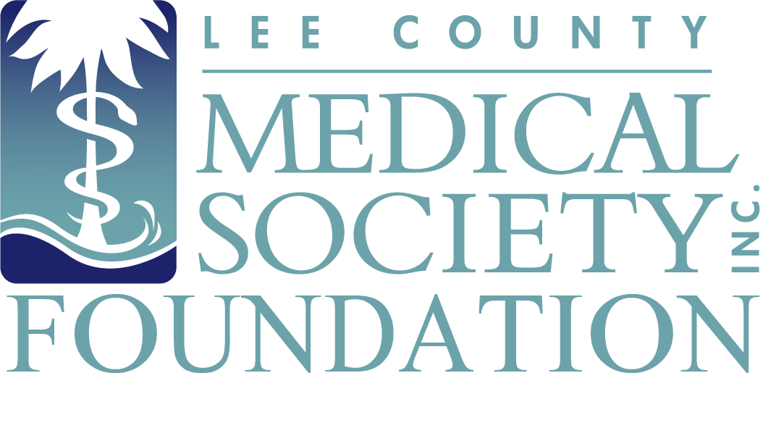
NEWS FOR IMMEDIATE RELEASE
Contact: Julie Ramirez, Executive Director
jramirez@lcmsfl.org
(239) 936-1645

Lee County Medical Society Foundation Honors Community Health Leaders

Fort Myers, FL (April 8, 2022) – The Lee County Medical Society (LCMS) Foundation held its 10th Annual Medical Service Awards to recognize local physicians and medical professionals for their outstanding contributions to healthcare in Lee County on April 2, 2022, at Lexington Country Club. Over 100 members of the medical community attended the event to give praise to the eight award recipients. Proceeds from the event benefit the Physician Wellness Program, a free and confidential mental health counseling program to combat burnout and improve the lives of LCMS physician members.

10th Annual Medical Service Awardees:

- Dr. Amber Jandik was awarded the Citizenship & Community Service Award for providing public service leadership above and beyond the call of duty as a practicing physician.
- Dr. Margaret Taha was awarded the Health Education Award in recognition of her professional and public health education activities.
- Dr. Marilyn Kole was awarded the Leadership & Professionalism Award for being a leader in medicine within the community.
- Dr. Sandy Cohen was posthumously awarded the Outstanding Physician Award for his substantial contributions to our medical community and for being a lifelong role model in the field of medicine.
- Lee Health System Respiratory Therapists were awarded the Non-Physician Award of Appreciation for their exemplary and lasting impact to medicine above and beyond the call of duty.
- The Florida Department of Health in Lee County was honored with the Distinguished Layperson’s Service Award for all its hard work that contributed to the achievement of the ideals of medicine through the advancement of medicine, medical science, medical research, medical education or medical care.
- Advocate Radiology (2020) and Florida Gynecological Oncology (2021) received the WeCare Award, which honors volunteer providers who support and deliver remarkable service and commitment to WeCare clients in Lee County.

“These medical and community healthcare providers showed a level of devotion to improving the health of the community during a very challenging time,” said LCMS President Dr. Tracy Vo. “Not only do they deserve an award and our recognition, but we also applaud them for what we know they will continue to do – provide exceptional care, leadership and compassion to everyone they serve in Lee County.”

The Annual Medical Service Awards is a public service event of the Lee County Medical Society Foundation, the charitable arm of the Lee County Medical Society, which is a professional organization of over 800 physician members practicing in Lee County, Florida. The Foundation supports the charitable efforts of physician members with an aim to improve the quality of life of its members and the public. Proceeds from Foundation events fund the Physician Wellness Program, which provides free psychological counseling to physicians so they can address normal life difficulties and avoid burnout. For more information, go to www.lcmsfl.org.

