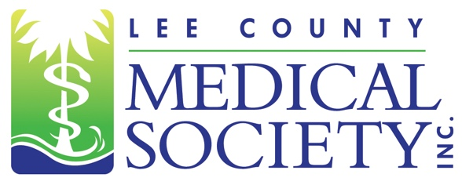
NEWS FOR IMMEDIATE RELEASE
Contact: Julie Ramirez, Executive Director
jramirez@lcmsfl.org
(239) 936-1645

First Pediatrician in Lee County Medical Society’s
History to Lead 2021 Board of Directors

Fort Myers, FL (February 9, 2020) – In a year that will test the healthcare community as it works to streamline processes for maximum delivery of the COVID-19 vaccine, the Lee County Medical Society (LCMS) is pleased to announce that its 2021 President is a Pediatrician with extensive experience navigating the vaccination process. In a small ceremony held on January 14, 2021, Dr. Annette St. Pierre-MacKoul was inducted as the Society’s 91st President.

“As a Pediatrician, our training instills the values of anticipatory guidance and preventive care,” said Dr. MacKoul during her acceptance speech. “Immunizations are the forefront of preventive care. I look forward to the challenges that we will face during 2021 and promise to assist in delivering real-time information on the availability of the coronavirus vaccine.”

A native of New York, Dr. St. Pierre-MacKoul earned her bachelor’s degree at Adelphi University and then attended Tufts University Medical School. She did her training and residency at the New England Medical Center’s Boston Floating Hospital before starting her first practice. Since relocating to Southwest Florida, Dr. St. Pierre-MacKoul has become involved with many community organizations including Healthy Start, Early Learning Coalition, PACE Center for Girls, Girls Going Places, and YMCA. She is a frequent medical contributor on local news shows and writes pediatric advice columns. In addition to her responsibilities as medical director of MacKoul Pediatrics Fort Myers, 2021 President of LCMS, Dr. St. Pierre-MacKoul is also a member of the National Board of Directors for the United Mitochondrial Disease Foundation and Infant Massage USA. She is also Medical Director for Family Initiative in Cape Coral.

The 2021 LCMS Board of Directors Executive Committee is: President Annette St. Pierre-MacKoul, MD; President-elect Tracy Vo, DO; Treasurer Ryan Lundquist, MD; Secretary Scott Caesar, MD; Past President Elizabeth Cosmai, MD; and Secretary-elect, Ethical & Judicial Affairs Chair Gamini Soori, MD.

LCMS would also like to recognize its 2021 Directors and Members at Large: Asif Azam, MD; Avra Carpousis-Bowers, MD; Justin Casey, MD; Arie Dosoretz, MD; E. Trevor Elmquist, DO; Janette Gaw, MD; Harmindar Gill, MD; Danielle Matta, MD; Ramon Pabalan, MD; and Ex Officio members: Stuart Bobman, MD; and John Schmidt, MD. Also assisting the Board is Executive Director Julie Ramirez.

Lee County Medical Society is a professional organization of over 800 physician members practicing in Lee County, Florida. Its mission is to advocate for physicians and their relationships with patients; promote public health and uphold the professionalism of the practice of medicine. Since 1927, the Society has been a trusted source of health policy leadership in Lee County. The Society also provides programs to educate physicians of all specialty areas while encouraging professional integrity and unity. In 2020, the Society transitioned to a permanent virtual office. For more information, go to www.lcmsfl.org.

