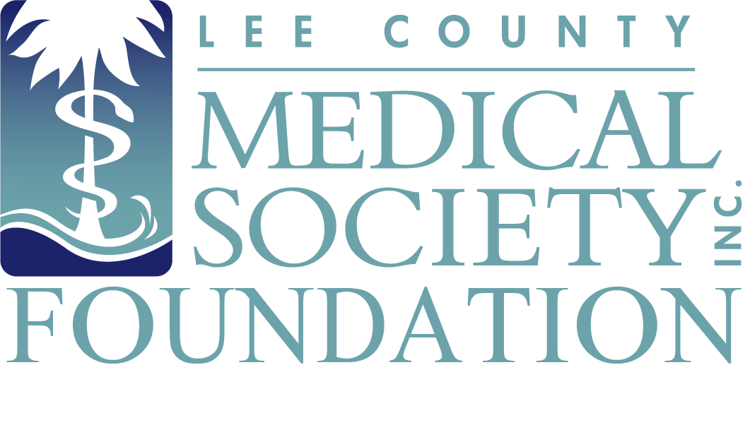
NEWS FOR IMMEDIATE RELEASE
Contact: Julie Ramirez, Executive Director
jramirez@lcmsfl.org
(239) 936-1645

Lee County Medical Society Foundation
to Honor Community Health Leaders on September 29, 2023

Fort Myers, FL (September 11, 2023) – The Lee County Medical Society (LCMS) Foundation will hold its 11th Annual Medical Service Awards to recognize local physicians and medical professionals for their outstanding contributions to healthcare in Lee County on September 29, 2023, at Forest Country Club. Members of the medical community and the public are invited to give praise to the nine award recipients. The event includes dinner, a tribute video, and awards ceremony. Proceeds will benefit the LCMS Physician Wellness Program, a free and confidential mental health counseling program to combat burnout and improve the lives of LCMS physician members.

11th Annual Medical Service Awardees:

- Dr. Ahsan Shah will be awarded the Citizenship & Community Service Award for providing public service leadership above and beyond the call of duty as a practicing physician.
- Dr. Arie Dosoretz will be awarded the Scientific Achievement Award for his outstanding work in scientific medical research.
- Advocate Radiation Oncology will be awarded the Health Education Award in recognition of its professional and public health education activities.
- Dr. Stephanie Stovall will be awarded the Leadership & Professionalism Award for reflecting the ideal professional characteristics of a practicing physician and being a leader in medicine within the community.
- Dr. Scott Larson will be awarded the Rising Star Award for exemplifying leadership, being a role model for others who have under 10 years of professional medical experience and bringing new technologies and talents to the area.
- Dr. Craig Sweet will be awarded the Lifetime Achievement Award for his substantial contributions to our medical community and for being a lifelong role model in the field of medicine.
- Meagan Walton, APRN, will be awarded the Non-Physician Award of Appreciation for her exemplary and lasting impact to medicine above and beyond the call of duty.
- Julie Ramirez, CAE, will be honored with the Distinguished Layperson’s Service Award for her keen leadership, initiative and hard work that contributed to improved access to medical and human services following Hurricane Ian.
- Associates in Dermatology will be presented with the WeCare Award, which honors volunteer providers who support and deliver remarkable service and commitment to WeCare clients in Lee County.

“Faced with challenges left in the wake of Hurricane Ian, these medical and community healthcare providers overcame obstacles with grace and are shining examples of a community’s devotion to help those in need and improve the delivery of healthcare to its residents,” said LCMS President Dr. Ryan Lundquist, MD “We are honored they call our area home and deserve an award and our recognition for providing exceptional care, leadership and compassion to everyone they serve in Lee County.”

LCMS Foundation would like to thank its Premier event sponsor FineMark National Bank & Trust. The Annual Medical Service Awards is a public service event of the Lee County Medical Society Foundation, the charitable arm of the Lee County Medical Society, which is a professional organization of over 800 physician members practicing in Lee County, Florida. The Foundation supports the charitable efforts of physician members with an aim to improve the quality of life of its members and the public. Proceeds from Foundation events fund the Physician Wellness Program, which provides free psychological counseling to physicians so they can address normal life difficulties and avoid burnout. This event is open to the public. Tickets are $100/per guest and can be purchased at www.lcmsfl.org/annual-medical-service-awards.org.

