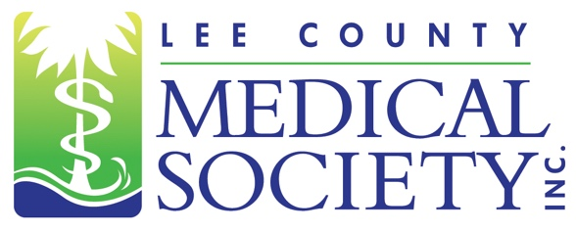
NEWS FOR IMMEDIATE RELEASE
Contact: Julie Ramirez, Executive Director
jramirez@lcmsfl.org
(239) 936-1645

Lee County Medical Society Installs 2024 Board of Directors

Fort Myers, FL (January 31, 2024) – The Lee County Medical Society (LCMS) is pleased to announce it officially installed its 2024 Board of Directors surrounded by LCMS members and guests on January 19, 2024. Newly inducted Board President Scott Caesar, MD, a urologist at University Urology, announced his presidential priorities for the upcoming year which will include hosting a job fair where members can recruit medical, nursing and allied health professionals; reshaping the Society’s social event calendar; expanding community engagement opportunities; meeting with physician-friendly candidates; and advocating for the mental health well-being of all healthcare providers in the area.

“I intend to show our physician members that their Society membership is more valuable than ever in 2024,” said Dr. Caesar. “We will do this by increasing the volume of our voice to candidates and politicians on legislative matters that impact our ability to deliver quality patient care, making our social networking events more fun, and hosting a job fair where our members can recruit top quality health professionals.”

The 2024 LCMS Board of Directors Executive Committee is: President Scott Caesar, MD; President-elect Gamini Soori, MD; Treasurer Asif Azam, MD; Secretary Arie Dosoretz, MD; and Past President Ryan Lundquist, MD.

LCMS would also like to recognize its 2024 Directors and Members at Large: Liliana Bustamante, MD; Justin Casey, MD; Lucia Huffman, MD; Kristina Mirabeau-Beale, MD; Jordan Taillon, MD; Magali Van Den Bergh, MD; and Ex Officio members: Stuart Bobman, MD; Stephanie Cruz, DO; and Amber Jandik, MD. Also assisting the Board is Executive Director Julie Ramirez, CAE.

Lee County Medical Society is a professional organization of over 800 physician members practicing in Lee County, Florida. Its mission is to advocate for physicians and their relationships with patients; promote public health and uphold the professionalism of the practice of medicine. Since 1927, the Society has been a trusted source of health policy leadership in Lee County. The Society also provides programs to educate physicians of all specialty areas while encouraging professional integrity and unity. In 2020, the Society transitioned to a permanent virtual office. For more information, go to www.lcmsfl.org.

